Intelligent Solar-Powered Vendo-Washing Machine
Using Embedded Systems

Submitted by:

Idos, Mark Anthony A
Ortigueras, Kate Valerie
Magnaye, Mark Javhen
Ruga, Jefferson

Submitted to:

_Mr. Christian Cabrera_
Instructor 1

Table of Contents

Project Overview 3.
Project Description 3.
Problem Statement 3.
Objectives Of the Study 3.
General Objective 4.
Scope and Limitations 4.
Scope of the Study 4.
Limitations of the Study 4.
System Architecture 5.
Architecture Description 5.
Data Flow 6.
Hardware Components .8.
Software Components 9.
Functional Requirements 9.
Non-Functional Requirements 10.
System Operation Procedure 11.
Gantt Chart 13.
Expected Output 15.
Development Period 15.
Proof of System Functionality 16.
Source Code 16.

Project Overview
This capstone project focuses on the design and development of an Intelligent Solar-Powered Vendo Washing Machine that integrates embedded systems and Internet of Things (IoT) analytics. The project aims to provide an automated and energy-efficient laundry solution by utilizing solar energy as its primary power source. An embedded control system is used to manage washing operations, user inputs, and system processes efficiently. The integration of sensors allows real-time monitoring of water levels, motor operation, and power consumption. IoT connectivity enables the collection and transmission of operational data to a cloud-based platform for monitoring and analysis. Through data analytics, system performance and usage patterns can be evaluated to support better maintenance and decision-making.

The vending feature allows users to conveniently access the washing service through a digital interface. By reducing dependency on grid electricity, the system promotes sustainable and environmentally friendly operation. The project also aims to demonstrate the effective integration of hardware and software components in a real-world application. Overall, the proposed system provides a smart, sustainable, and innovative solution for modern automated laundry services.

Project Description
The proposed system is a vending-type washing machine that operates using solar-generated power stored in a battery system. An embedded controller manages the core functions of the machine, including washing cycle control, water level regulation, motor operation, and user interaction. A digital payment and selection interface allows users to conveniently access the service.

In addition, IoT technology is integrated to enable remote monitoring and data transmission to a cloud-based platform. Operational data such as energy consumption, usage frequency, system status, and error conditions are collected and analyzed to support maintenance, performance evaluation, and decision-making. The combination of hardware and software components ensures automation, efficiency, and sustainability, making the system suitable for dormitories, apartments, laundry stations, and areas with limited access to grid electricity.

Problem Statement
Despite the widespread use of washing machines, several challenges continue to limit their efficiency, accessibility, and sustainability, particularly in areas with high energy costs and unstable power supply. This study seeks to address the following specific problems:
- High Dependency on Grid Electricity – Conventional washing machines rely primarily on grid-based power, resulting in increased electricity costs and limiting their usability in areas with unstable or unavailable power supply.
- Lack of Renewable Energy Utilization – Most existing vending or public washing machines do not utilize renewable energy sources, contributing to higher carbon emissions and inefficient energy consumption.
- Absence of Intelligent Monitoring and Analytics – Traditional washing machines lack real-time monitoring and data analytics, making it difficult to track energy usage, machine status, system performance, and maintenance requirements.
- Inefficient Resource Management – Without sensor-based automation, water and power usage are often not optimized, leading to wastage and increased operational costs.
- Limited Automation in Vending-Based Laundry Systems – Existing vending washing machines often provide basic functionality without intelligent control, remote monitoring, or automated alerts for system errors and maintenance needs.
- Poor Accessibility in Remote or Off-Grid Locations – The absence of a sustainable power source limits the deployment of washing machines in rural or off-grid areas where laundry services are still neede

In response to these problems, the study formulates specific and general objectives that directly address each identified issue. The Objectives of the Study provide targeted solutions to the problems by defining the required hardware and software functions, system automation, energy optimization, and IoT-based monitoring features.

The General Objective further explains and unifies these solutions by presenting the overall goal of developing an intelligent, solar-powered, and data-driven vending washing machine that effectively resolves the stated problems through embedded systems and IoT analytics.

Objectives of the Study
The objectives of this study are to:
- Design and develop a solar-powered vendo washing machine using embedded system technology.
- Integrate hardware components such as solar panels, batteries, sensors, and actuators for efficient system operation.
- Develop software for controlling washing cycles, user interaction, and vending functionality.
- Implement IoT connectivity for real-time monitoring and data analytics.
- Optimize energy and water usage through sensor-based automation.
- Evaluate the functionality, efficiency, and reliability of the proposed system.

General Objective
To develop an intelligent solar-powered vendo washing machine that integrates embedded systems and IoT analytics to provide an automated, energy-efficient, and data-driven laundry service.

Scope and Limitations
This study focuses on the design, development, and testing of a prototype-level intelligent solar-powered vendo washing machine. It covers both hardware and software components, including solar energy harvesting, embedded control systems, sensor integration, user interface design, and IoT-based data monitoring. System testing is conducted under controlled conditions to evaluate basic performance and functionality.

The project is limited to small- to medium-scale applications and does not include large-scale commercial deployment or industrial-grade washing systems.

Scope of the Study
The scope of the study includes:
- Solar power generation and battery-based energy storage
- Embedded system control for washing operations
- User interface and vending/payment mechanism
- Sensor integration for monitoring water level, motor status, and power usage
- IoT-based data transmission, monitoring, and basic analytics
The study evaluates system performance in terms of automation, energy efficiency, and operational reliability.

Limitations of the Study
The performance of the system is dependent on the availability of solar energy, which may be affected by weather conditions and environmental factors. Battery capacity limitations may restrict continuous operation during prolonged periods of low sunlight. Internet connectivity is required for real-time IoT data transmission and monitoring, and interruptions in connectivity may affect data availability.

- Dependence on Solar Energy Availability
The system relies primarily on solar power, which is dependent on sunlight availability. Weather conditions such as cloudy or rainy days may affect energy generation and system performance.
- Battery Capacity Constraints
The system uses battery storage to operate during low or no sunlight conditions. However, limited battery capacity may restrict continuous operation, especially during extended periods of insufficient solar energy.
- Internet Connectivity Dependency
IoT features such as real-time monitoring and data transmission require a stable internet connection. Interruptions or poor connectivity may result in delayed or unavailable data updates.
- Prototype-Level Implementation
The study is limited to the development of a prototype system. It does not include full-scale commercial deployment or industrial-grade washing machine integration.
- Limited System Durability Testing
Long-term durability, wear-and-tear analysis, and extended operational testing are not covered within the scope of this study.
- Basic Data Analytics Only
The system utilizes basic data monitoring and analysis. Advanced analytics techniques, such as machine learning or predictive maintenance, are not implemented.
- Scalability Limitations
The system is designed for small- to medium-scale applications only. Expansion to large-scale operations or multiple-unit deployment is not included.

This study is limited to prototype implementation and does not cover long-term durability testing, large-scale commercial use, or advanced data analytics such as machine learning-based optimization.

System Architecture
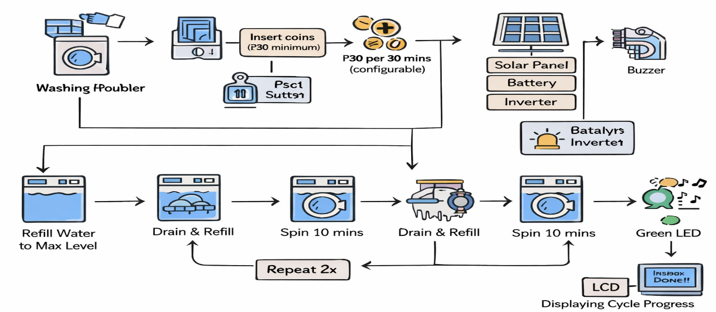

Figure 1: System Architecture

Architecture Description

The system architecture of the Intelligent Solar-Powered Vendo Washing Machine Using Embedded Systems and IoT Analytics is composed of several interconnected components that work together to enable automated, energy-efficient, and intelligent laundry operations based on a coin-operated washing process..

Power System Components
- Solar Panel Array
Converts sunlight into electrical energy, serving as the primary power source of the system.
- Charge Controller
Regulates the voltage and current from the solar panels to safely charge the battery and prevent overcharging or damage.
- Battery Bank
Stores electrical energy generated by the solar panels to ensure continuous system operation during low or no sunlight conditions.
- Inverter
Converts stored DC power from the battery into AC power required by the washing machine and other components.
Control and Processing Component
- Embedded Control System (Microcontroller)
Acts as the central processing unit of the system. It receives inputs from the coin interface, buttons (start/stop), and sensors, processes the data, and controls all system operations including washing cycles, spinning time, water refilling, draining, and system timing logic.
User Input / Vending Component
- Coin Payment Interface
Allows users to insert coins to activate the washing machine. The system requires a minimum amount (e.g., ₱30 for 30 minutes, configurable). The washing process will not start unless the required amount is met.
- Start Button
Allows the user to manually start the washing process after meeting the required coin amount.
- Stop Button (Manual Override)
Provides a manual control to stop the washing operation at any time during the process.
Sensing and Actuation Components
- Water Level Sensor
Monitors the water level inside the washing machine. It ensures that water reaches the required maximum level before starting the washing or spinning process.
- Motor Control
Controls the operation of the washing machine motor, including spinning during washing and rinsing cycles.
- Water Pump and Valve
Regulates water intake and drainage during different stages such as initial filling, draining after washing, and refilling for rinsing cycles.

- Buzzer
Provides audio alerts during key stages of the operation, such as before rinsing and when the washing cycle is complete.
- LED Indicator (Red/Green)
Indicates the system status:
- Red LED – Machine is operating
- Green LED – Washing cycle is complete
Machine Operation Components
- Vendo Washing Machine Unit
The main physical unit where clothes are placed along with detergent. It performs washing, rinsing, and spinning operations controlled by the microcontroller.
- Washing Cycle Control
Executes the programmed sequence of operations based on system logic:
- Water filling until maximum level
- 10 minutes washing (spinning)
- Drain and refill
- First rinsing cycle (10 minutes spinning)
- Drain and refill
- Second rinsing cycle (10 minutes spinning)
- Final completion
The system pauses time during draining and refilling processes.
- LCD Display
Displays real-time system progress and status updates such as washing stage, time remaining, and cycle transition

Data Flow
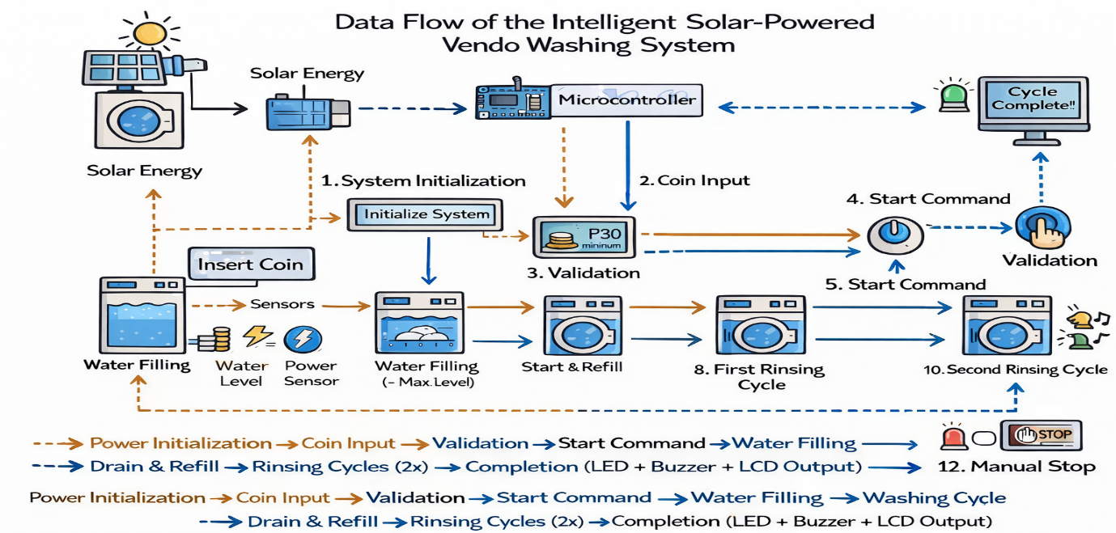

Figure 2: Data Flow

The data flow of the Intelligent Solar-Powered Vendo Washing Machine System describes how user input, sensor data, and control signals move within the system to perform automated washing operations. The system operates locally using a microcontroller without relying on cloud-based communication.

- Solar Power Generation
The process begins with the solar panel array, which collects sunlight and converts it into electrical energy to supply the system.

- Energy Storage
The generated energy is stored in the battery system, which provides stable power for the washing machine and control components.

- Control Center Processing
The stored power is supplied to the control center (microcontroller), which acts as the main processing unit of the system and manages all operations.

- Coin Inserted
The user inserts a coin into the coin interface. This serves as the input signal that requests access to the washing service.

- Coin Validation and Start Command
The coin input is detected and processed by the microcontroller. The system checks if the required minimum amount (e.g., ₱30) is met. Once validated, the user can press the start button, and the system sends a command to begin the washing cycle.

- Water Filling Process
The system activates the water pump and valve to fill the washing machine. The water level sensor continuously sends data to the microcontroller until the required maximum level is reached.

- Washing Process Execution
Once the correct water level is reached, the microcontroller activates the motor for the washing process (10 minutes spinning). The LCD displays the progress of the operation.

- Drain and Refill Process
After the washing cycle, the system stops the motor, drains the water, and refills the machine with clean water. The timer pauses during this stage.

- First Rensing Cycle
The system performs the first rinsing process by activating the motor for another 10 minutes. The red LED remains ON, indicating that the machine is still in operation. The buzzer may sound to notify the rinsing stage.

- Second Drain and Refill
The system again drains the used water and refills the machine. The LCD updates the current process, and the buzzer provides an alert.

- Second Rensing Cycle
The system performs the second rinsing cycle (10 minutes spinning). This completes the rinsing process (2 sets).

- Cycle Completion
After completing all cycles:
- The motor stops
- The red LED turns OFF
- The green LED turns ON
- The buzzer sounds to indicate completion
- The LCD displays “Cycle Complete”

- Manual Stop (Override Flow)
At any point during operation, the user may press the stop button, which sends a signal to the microcontroller to immediately stop all operations.

Overall Data Flow Sequence

Solar Power Generation → Energy Storage → Control Center → Coin Insertion → Validation → Start Command → Water Filling → Washing Cycle → Drain & Refill → Rinsing Cycles (2x) → Completion (LED + Buzzer + LCD Output)

Hardware Components

Component | Description | Recommended Requirement
Solar Panel | Converts sunlight into electrical energy | 100W Monocrystalline Solar Panel
Charge Controller | Regulates charging of battery from solar panel | MPPT Controller
Battery | Stores electrical energy for system use | 12V Lithium Deep Cycle Battery (30Ah)
Inverter | Converts DC to AC power | Pure Sine Wave Inverter
Microcontroller (ESP32) | Main control unit of the system | ESP32 (Wi-Fi capable)
Coin Acceptor | Detects and validates inserted coins | Programmable Coin Acceptor
Relay Module | Controls switching of motor and devices | 4-Channel Relay Module
Water Level Sensor | Detects water level inside the machine | Ultrasonic Water Level Sensor
Solenoid Valve | Controls water intake | 12V Solenoid Valve
Washing Machine Unit | Main washing system | Portable Washing Machine
LCD Display (20x4 I2C) | Displays system status and progress | 20x4 I2C LCD Display
Push Buttons | User input controls (Start/Stop) | Heavy Duty Push Buttons
LEDs | Indicator lights (Red/Green) | High-brightness LEDs
Buzzer | Audio alert system | Active Buzzer Module
Wiring & Connectors | Electrical connections | Industrial-grade Wiring
Power Supply Unit | Provides regulated voltage | Regulated Power Module
Breakers | Electrical protection | Circuit Breakers (10A/20A)
Electrical Outlet | Power output connection | Heavy-duty Outlet
Building Frame Materials | Structural support (metal/wood frame) | Steel/Wood Frame Construction

Table 1: Hardware Components

Software Components

Software | Purpose | Minimum Requirement | Recommended Requirement
Arduino IDE | Used for programming the microcontroller | Arduino IDE Installed | Latest Arduino IDE
Embedded C/C++ | Programming language for system logic | Basic Syntax | Structured & Modular Code
Wi-Fi Module (ESP32 built-in) | Enables IoT communication | ESP8266 Module | ESP32 (integrated Wi-Fi)

Table 2: Software Components

Functional Requirements

This section discusses the core functional requirements of the intelligent solar-powered vendo washing machine system. Each requirement defines a specific behavior that the system must perform to ensure efficient, automated, and reliable laundry operations.

- The system shall generate electrical power using solar energy
The system is required to capture sunlight through solar panels and convert it into electrical energy. This generated power serves as the primary energy source of the system, reducing dependency on grid electricity and promoting sustainable operation.

- The system shall store energy in a battery system
The system must store generated solar energy in a battery for continuous operation. This ensures that the washing machine can still function during periods of low sunlight or at night, maintaining system availability.

- The system shall accept and validate coin input
The system is required to detect and validate coins inserted by users through a coin acceptor module. Only valid coins will trigger the system to proceed, ensuring proper payment control for the vending operation.

- The system shall activate the washing machine upon valid payment
After coin validation, the system must automatically activate the washing machine. This function eliminates manual intervention and enables a self-service laundry process.

- The system shall automate the washing cycle
The system must control the complete washing process, including washing, rinsing, and draining. The washing cycle is executed based on predefined logic programmed into the microcontroller.

- The system shall monitor water levels
The system must use sensors to detect and regulate water levels inside the washing machine. This ensures that the correct amount of water is used during each stage of the washing process and prevents overflow or insufficient water conditions.

- The system shall control motor operation
The system must manage the operation of the washing machine motor during washing and spinning cycles. This ensures proper agitation and cleaning performance.

- The system shall control water flow
The system must regulate water intake and drainage using pumps and valves. This allows efficient management of water usage throughout the washing cycle.

- The system shall display system status
The system must provide real-time feedback to users through a display interface. Status messages such as “Insert Coin,” “Washing,” and “Cycle Complete” inform users about the current operation of the machine.

- The system shall transmit operational data to the cloud
The system must send data such as system status, usage information, and sensor readings to a cloud-based platform. This enables remote monitoring and data storage.

- The system shall provide remote monitoring capability
The system must allow users or administrators to monitor machine status through a web dashboard or mobile application. This function supports real-time monitoring and system management.

- The system shall store system data for analysis
The system must store operational data in a centralized database. This allows tracking of usage patterns, performance evaluation, and maintenance planning.

Together, these functional requirements define the essential operations of the system—from energy generation and payment validation to washing control and data monitoring. By fulfilling these requirements, the system ensures automated, efficient, and accessible laundry service using embedded systems and IoT technology.

Non-Functional Requirements

This section discusses the non-functional requirements of the intelligent solar-powered vendo washing machine system. These requirements define the quality attributes of the system and describe how well the system performs its functions rather than what functions it performs.

- Performance
The system is required to respond within two (2) seconds after a coin is inserted. This ensures a fast and smooth user experience, preventing delays in activating the washing process.

- Security
The system must implement basic security measures for cloud access and data transmission. Only authorized users should be able to access system data through the dashboard, ensuring protection of operational information.

- Reliability
The system must maintain consistent performance during operation. Data collected from sensors and system processes should be accurately transmitted and stored without loss or corruption.

- Scalability
The system must be capable of supporting additional units or expanded deployment without significant performance degradation. This allows the system to be adapted for larger laundry operations.

The non-functional requirements define the system’s expected performance level, security safeguards, reliability of operations, and ability to scale. Meeting these requirements ensures that the intelligent vendo washing machine system is not only functional but also efficient, dependable, and suitable for real-world applications.

Systems Operation Procedure

This section describes the step-by-step procedure for operating the Intelligent Solar-Powered Vendo Washing Machine System. The procedure outlines the normal sequence of actions required to ensure proper system functionality from startup to completion of the washing cycle.

Step 1:
Power Initialization

The system begins by generating electrical power through the solar panel array. The generated energy is regulated by the charge controller and stored in the battery system. Once sufficient power is available, the system initializes all components, including the microcontroller, sensors, coin acceptor, and communication modules. This step prepares the system for operation.

Step 2:
System Readiness

After initialization, the system enters a standby mode. The display interface shows a message such as “Insert Coin,” indicating that the machine is ready for user input. All sensors and control components remain active while waiting for a valid transaction.

Step 3:
Coin Insertion

The user inserts a coin into the coin acceptor. The system detects the coin and sends a signal to the microcontroller for validation. This step serves as the input that initiates the washing process.

Step 4:
Coin Validation

The microcontroller processes the input from the coin acceptor and verifies whether the inserted coin is valid. If the coin is accepted, the system proceeds to the next step. If invalid, the system rejects the input and remains in standby mode.

Step 5:
Activation of Washing Cycle

Once a valid coin is detected, the system activates the washing machine. The microcontroller sends control signals to the relay modules, enabling the motor, water pump, and valves to begin operation.

Step 6:
Water Filling Process

The system activates the water valve and pump to fill the washing machine with water. The water level sensor continuously monitors the water level to ensure it reaches the required amount. Once the desired level is achieved, the system automatically stops water intake.

Step 7:
Washing Operation

The washing motor is activated, and the system performs the washing process based on a predefined time interval. The microcontroller controls the motor speed and duration to ensure effective cleaning.

Step 8:
Rinsing Process

After washing, the system drains the used water and refills the machine with clean water. The rinsing cycle is executed to remove detergent residues from the clothes.

Step 9:
Draining and Spinning

The system activates the drainage mechanism to remove water from the machine. The motor then performs the spinning process to extract excess water from the clothes.

Step 10:
System Monitoring and Data Transmission

During operation, the system continuously collects data such as water level, motor status, and energy usage. This data is transmitted to the cloud server through the IoT module for monitoring and analysis.

Step 11:
Cycle Completion

Once the washing cycle is complete, the system automatically stops all operations. The display shows a message such as “Cycle Complete,” informing the user that the process has finished.

Step 12:
System Reset and Ready State

After completion, the system resets and returns to standby mode. The display again shows “Insert Coin,” indicating that the machine is ready for the next user.

The system operation procedure ensures a smooth, automated, and efficient laundry process. By following these steps, the system provides a user-friendly and reliable self-service washing experience powered by solar energy and controlled through embedded systems and IoT technology.

Gantt Chart

Idos, Mark Anthony A
TASK/PHASE | APRIL – MAY 2026
 | WEEK 1 | WEEK 2 | WEEK 3 | WEEK 4 | WEEK 5 | WEEK 6 | WEEK 7 | WEEK 8
Project Planning & proposal |  |  |  |  |  | Final Exam Week
Requirements Analysis
System Architecture Design
Hardware Setup & Wiring
Firmware Development (ESP32/Arduino)
Data Storage Configuration
System Integration
Testing and Debugging
Documentation Writing
Final Evaluation & Submission

Magnaye, Mark Javhen
TASK/PHASE | APRIL – MAY 2026
 | WEEK 1 | WEEK 2 | WEEK 3 | WEEK 4 | WEEK 5 | WEEK 6 | WEEK 7 | WEEK 8
Project Planning & proposal |  |  |  |  |  | Final Exam Week
Requirements Analysis
System Architecture Design
Hardware Setup & Wiring
Firmware Development (ESP32/Arduino)
Data Storage Configuration
System Integration
Testing and Debugging
Documentation Writing
Final Evaluation & Submission

Ortigueras, Kate Valerie
TASK/PHASE | APRIL – MAY 2026
 | WEEK 1 | WEEK 2 | WEEK 3 | WEEK 4 | WEEK 5 | WEEK 6 | WEEK 7 | WEEK 8
Project Planning & proposal |  |  |  |  |  | Final Exam Week
Requirements Analysis
System Architecture Design
Hardware Setup & Wiring
Firmware Development (ESP32/Arduino)
Data Storage Configuration
System Integration
Testing and Debugging
Documentation Writing
Final Evaluation & Submission

Ruga, Jefferson
TASK/PHASE | APRIL – MAY 2026
 | WEEK 1 | WEEK 2 | WEEK 3 | WEEK 4 | WEEK 5 | WEEK 6 | WEEK 7 | WEEK 8
Project Planning & proposal |  |  |  |  |  | Final Exam Week
Requirements Analysis
System Architecture Design
Hardware Setup & Wiring
Firmware Development (ESP32/Arduino)
Data Storage Configuration
System Integration
Testing and Debugging
Documentation Writing
Final Evaluation & Submission

Expected Output

The expected outputs of the Intelligent Solar-Powered Vendo Washing Machine System Using Embedded Systems and IoT Analytics are the following:

- Automated Washing Operation
The system provides a fully automated washing process that begins upon coin insertion. It performs washing, rinsing, and draining without requiring manual intervention, ensuring convenience and efficiency for users.

- Solar-Powered Energy Utilization
The system operates primarily using solar energy, reducing dependency on grid electricity. This promotes energy efficiency and supports environmentally friendly operation.

- Coin-Operated Vending Functionality
The system allows users to access the washing service through a coin-based payment mechanism. This enables a self-service setup suitable for public use such as dormitories, apartments, and communities.

- Efficient Water and Power Management
The integration of sensors and automated control ensures proper water level monitoring and optimized use of energy, minimizing resource wastage.

- Functional Prototype System
The final output includes a working prototype of a solar-powered vendo washing machine that demonstrates the integration of embedded systems, automation, and IoT technology in a real-world application.

The expected outputs highlight the system’s ability to deliver an automated, energy-efficient, and intelligent laundry solution. By achieving these outputs, the project demonstrates the practical application of embedded systems and IoT in improving accessibility and efficiency in laundry services.

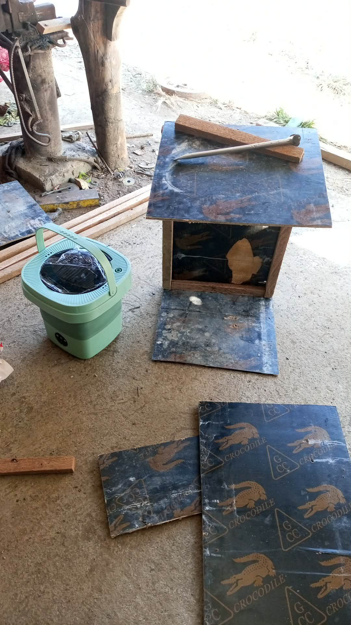
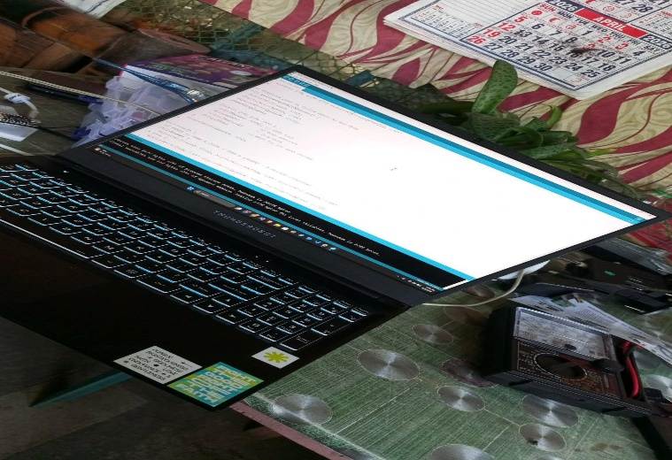
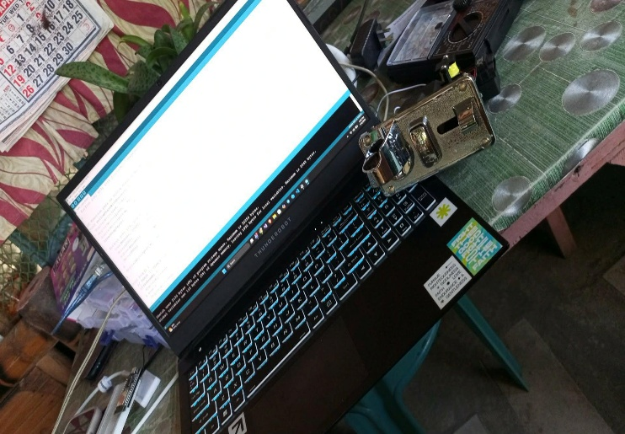
Development Period

During the first (1st) to second (2nd ) week of the Month of April, were just coordinating with our instructor Mr. Cabrera regarding purchasing our hardware components, during those weeks we continue to coordinate verify with the specification of the components needed to develop this project.
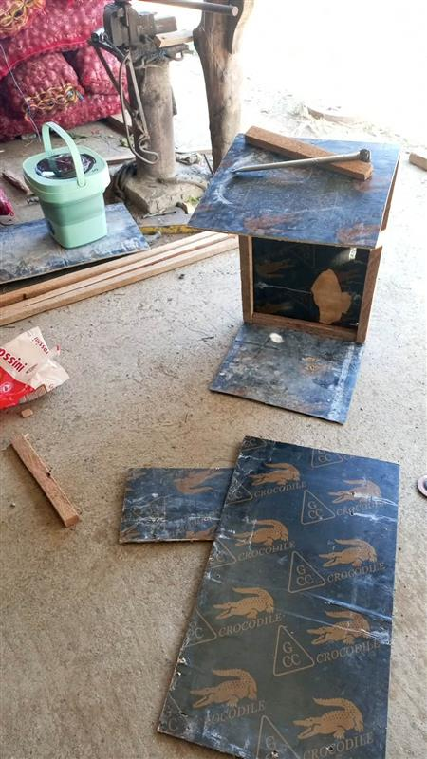
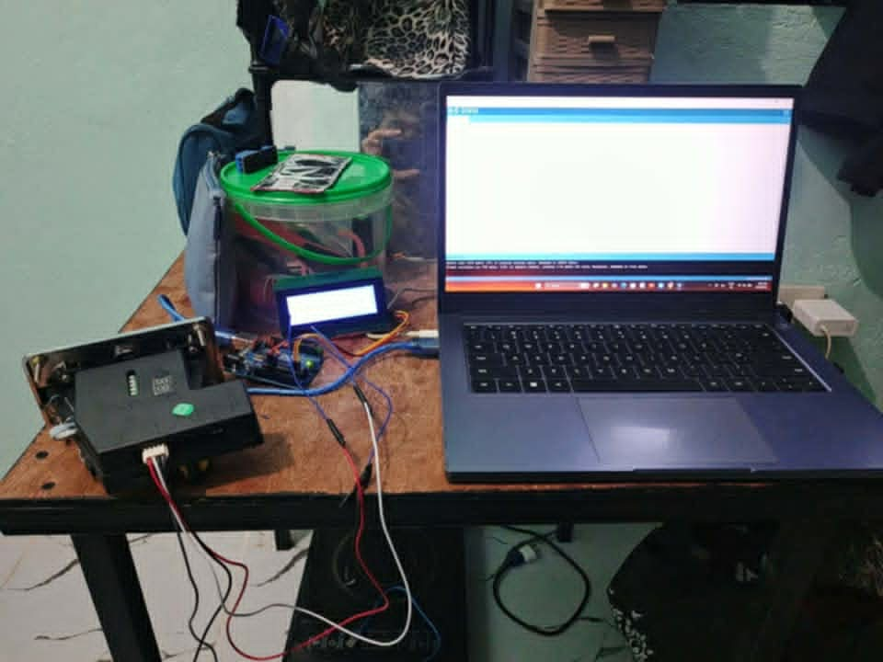
At this stage although we are running behind schedule, we are already at configuration stage of components. Since weve already created the frame for this project.

Proof of System Functionality

Source Code

#include <Wire.h>
#include <LiquidCrystal_I2C.h>

LiquidCrystal_I2C lcd(0x27, 20, 4);

const int coinPin = 2;
const int stopButton = 3;
const int relayMotor = 7;

unsigned long remainingTime = 0;
unsigned long lastUpdate = 0;
bool isPaused = false;
bool lastScreenWasIdle = true;

// --- SUPER STABLE COIN FILTER ---
int lastCoinReading = HIGH;
int stableCoinState = HIGH;
unsigned long lastCoinDebounce = 0;
const int coinDebounceDelay = 30; // 30ms na steady LOW bago tanggapin
unsigned long lastCoinTime = 0;
const int coinGap = 500; // Gap sa pagitan ng bawat hulog (500ms)

// --- BUTTON STABILITY ---
int lastButtonState = HIGH;
int stableButtonState = HIGH;
unsigned long lastDebounceTime = 0;
unsigned long debounceDelay = 80;

void setup() {
lcd.init();
lcd.backlight();
pinMode(coinPin, INPUT_PULLUP);
pinMode(stopButton, INPUT_PULLUP);
pinMode(relayMotor, OUTPUT);
digitalWrite(relayMotor, HIGH);
showIdleMessage();
}

void loop() {
unsigned long currentMillis = millis();

// 1. IMPROVED COIN DETECTION (Anti-Continuous)
int currentCoinReading = digitalRead(coinPin);

if (currentCoinReading != lastCoinReading) {
lastCoinDebounce = currentMillis;
}

if ((currentMillis - lastCoinDebounce) > coinDebounceDelay) {
if (currentCoinReading != stableCoinState) {
stableCoinState = currentCoinReading;

// Magdadagdag LANG kung ang confirmed state ay naging LOW
if (stableCoinState == LOW) {
if (currentMillis - lastCoinTime > coinGap) {
remainingTime += 239; // Dagdag 3:59
isPaused = false;
lastCoinTime = currentMillis;
lcd.clear();
}
}
}
}
lastCoinReading = currentCoinReading;
// 2. STABLE BUTTON LOGIC
int currentButtonReading = digitalRead(stopButton);
if (currentButtonReading != lastButtonState) {
lastDebounceTime = currentMillis;
}
if ((currentMillis - lastDebounceTime) > debounceDelay) {
if (currentButtonReading != stableButtonState) {
stableButtonState = currentButtonReading;
if (stableButtonState == LOW && remainingTime > 0) {
isPaused = !isPaused;
lcd.clear();
}
}
}
lastButtonState = currentButtonReading;

// 3. TIMER AND MOTOR CONTROL
if (currentMillis - lastUpdate >= 1000) {
lastUpdate = currentMillis;
if (remainingTime > 0) {
if (!isPaused) {
remainingTime--;
digitalWrite(relayMotor, LOW);
updateDisplay();
lastScreenWasIdle = false;
} else {
digitalWrite(relayMotor, HIGH);
showPausedMessage();
}
} else {
digitalWrite(relayMotor, HIGH);
isPaused = false;
if (!lastScreenWasIdle) {
lcd.clear();
showIdleMessage();
lastScreenWasIdle = true;
}
}
}
}

// --- DISPLAY FUNCTIONS ---
void showIdleMessage() {

lcd.setCursor(0, 0); lcd.print(" VENDO WASH ");
lcd.setCursor(0, 1); lcd.print("--------------------");
lcd.setCursor(0, 2); lcd.print(" INSERT 5 PESO COIN ");
lcd.setCursor(0, 3); lcd.print(" STATUS: READY ");
}

void showPausedMessage() {
lcd.setCursor(0, 0); lcd.print(" VENDO WASH ");
lcd.setCursor(0, 1); lcd.print("--------------------");
lcd.setCursor(0, 2); lcd.print(" * PAUSED * ");
lcd.setCursor(0, 3); lcd.print(" PRESS TO RESUME ");
}

void updateDisplay() {
int mins = remainingTime / 60;
int secs = remainingTime % 60;
lcd.setCursor(0, 0); lcd.print(" WASHING ACTIVE ");
lcd.setCursor(0, 1); lcd.print("====================");
lcd.setCursor(0, 2); lcd.print(" TIME LEFT: ");
if (mins < 10) lcd.print("0"); lcd.print(mins);
lcd.print(":");
if (secs < 10) lcd.print("0"); lcd.print(secs);
lcd.print(" ");
lcd.setCursor(0, 3); lcd.print(" STATUS: RUNNING... ");
}

